Largest Paper cup

The Largest Paper Cup Mosaic by a Team was achieved by 400 participants of Vasavi Vidhyalaya Matriculation School, Trichy District, Tamil Nadu, India on February 10, 2013. It measured 1076.50 square feet (3281 feet in length and 32.81 feet in breadth).
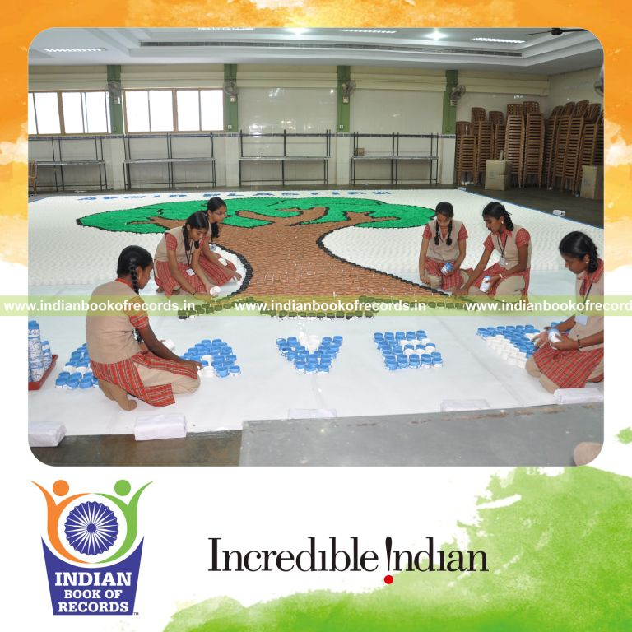.

Paper Arrow
Paper Arrows Simultaneously (Single Venue) for 5 minutes counted to 400 participants. It was accomplished by Vasavi Vidhyalaya Matriculation School, Trichy-620 001.
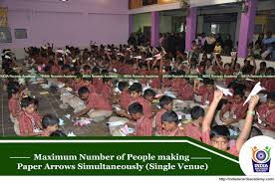
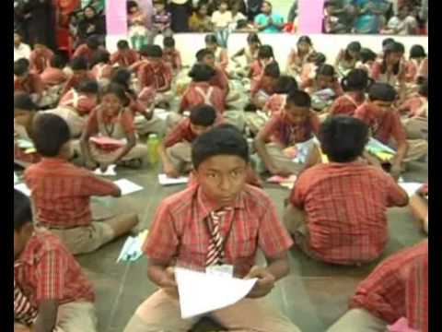

Toothpick (Individual Performance)
The Largest Toothpick Mosaic by a Minor (Female) measured 16 square meters (4 meters in length and 4 meters in breadth), was set by K. Rajeswari, Class VII of Vasavi Vidhyalaya Matriculation School, Trichy, Tamil Nadu, India on February 10, 2013.

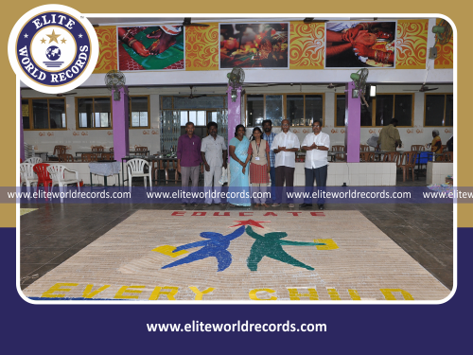

Longest Finger Paint
The Longest Finger Painting measured 400 Meters (400 Meters length and 1 Meter breadth) was achieved by a team of 400 participants of Vasavi Vidhyalaya Matriculation School, Trichy, Tamil Nadu, India on February 9, 2013. It reflected paintings emphasizing the concept “Prevent Pollution”.

